- Create an HTML page that displays an image of your choice. When a user clicks on the image, it should redirect to your university website.
OUTPUT:



- Design an HTML table to store student records with columns: Roll No, Name, Course, Marks, Grade. Ensure the table has a heading row and at least 5 rows of data.

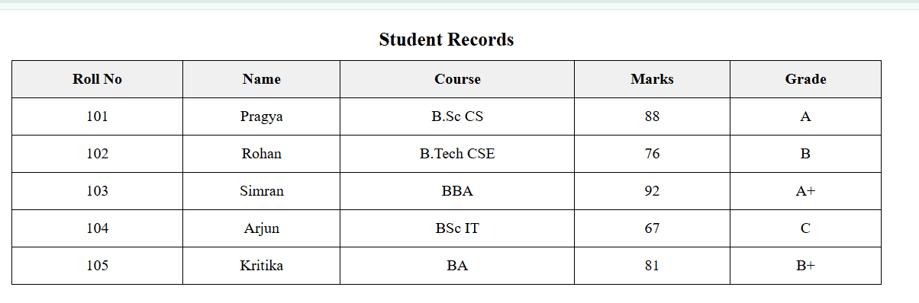

- Build an HTML form that asks the user for their Name, Email, Gender (radio buttons), Favourite Subject (dropdown), and Comments (textarea). Add a Submit butt on.
OUTPUT:

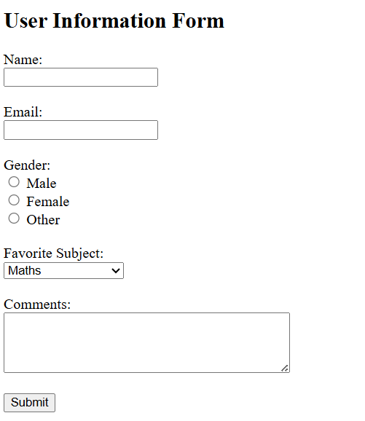

- Create a simple navigation bar with links to Home, About, Courses, and Contact using an unordered list (<ul>).
OUTPUT:



- Design a webpage that embers an audio file (mp3) and a video file (mp4) with control so that user can play /pause them.
OUTPUT:
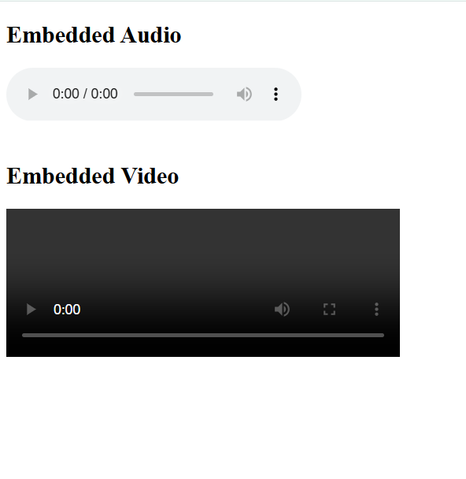

PRACTICAL ASSIGNMENT UNIT 2
- Demonstrate understanding of the Box Model and Display: inline -block.

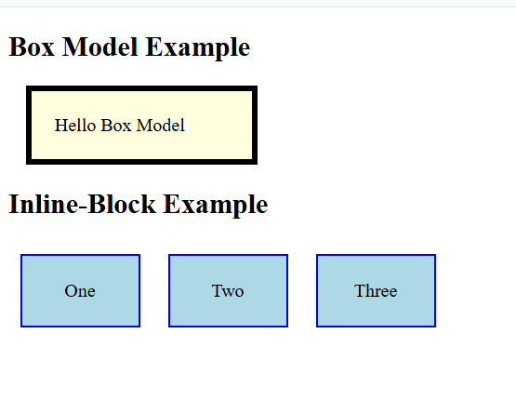

Q2. Create a container <div> with the class flex-container. Inside, place three small boxes (inner <div>s) labled A, B, and C.
Use display: flex on the flex-container to place the boxes side-byside. Use jus fy-content to place space between the boxes.
Use a Media Query to change the layout: When the screen width is 600px or less (@media (max-width: 600px)), change the flexdirec on to column so the boxes stack ver cally.
OUTPUT:

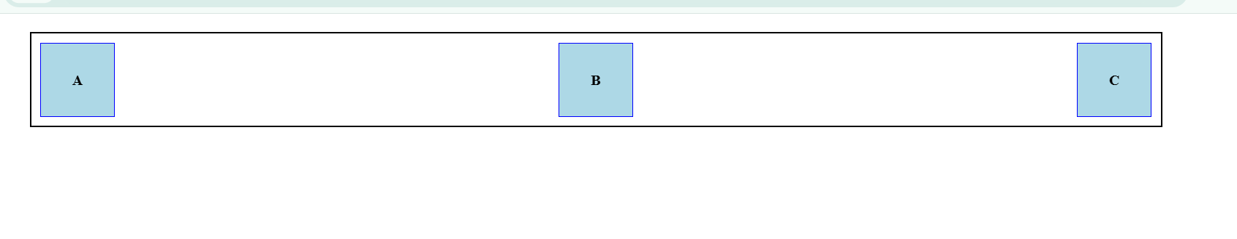

Q3. Create a standard text input field (<input type="text">). Set the ini al border to 1px solid gray.
Apply a transi on to the border-colour and transform proper es with a dura on of
0.4 seconds.
Use the: focus pseudo-class to style the input when the user clicks into it: Change the border colour to a bright green.
Use the transform property to slightly rotate the input by 15 degrees (e.g., rotate(15deg)) OUTPUT:

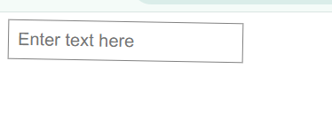

PRACTICAL ASSIGNMENT UNIT 3
- Count how many even and odd numbers are there. OUTPUT:

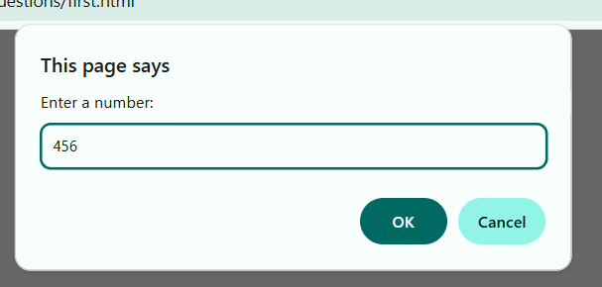

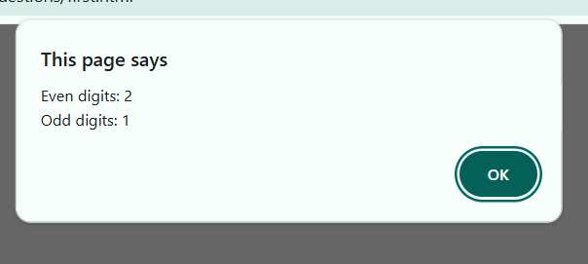

- Remove duplicate values from an array.
OUTPUT:
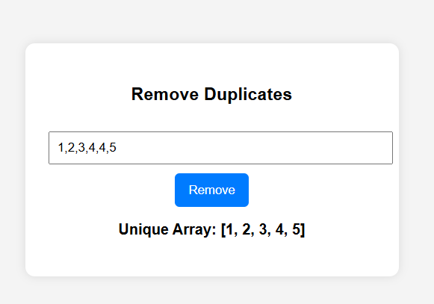

- Find the sum of all numbers in an array.
OUPUT:
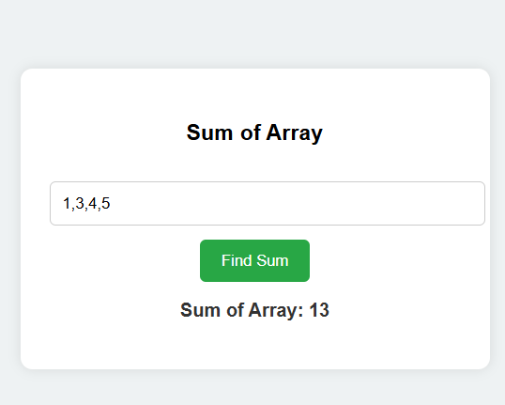

PRACTICAL ASSIGNMENT UNIT 4
1.WRITE AN ARROW FUNCTON IS EVEN THAT RETURN TRUE IF A NUMBER IS EVEN

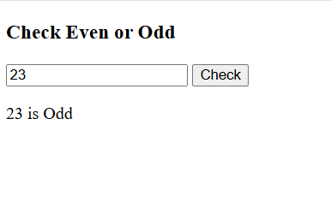

- CREATE A MULTILINE STRING USING TEMPLATES LITERAR SHOWING A 3 LINE MESSAGE OUTPUT:
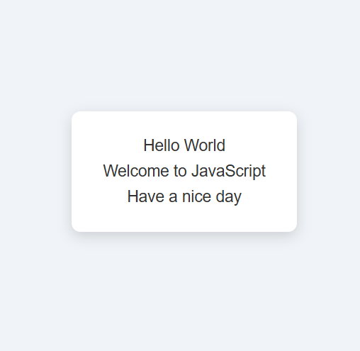

MERGE TWO ARRAY USING THE SPEED OPERATOR
OUTPUT:
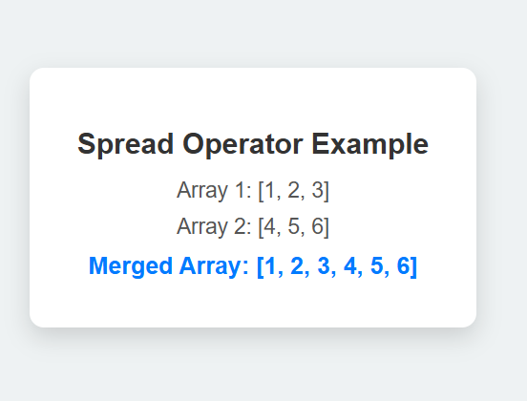

- ADD A CLICK EVENT TO A BOTTOM THAT CHANGES THE TEXT OF A PARAGRAPH.
OUTPUT:
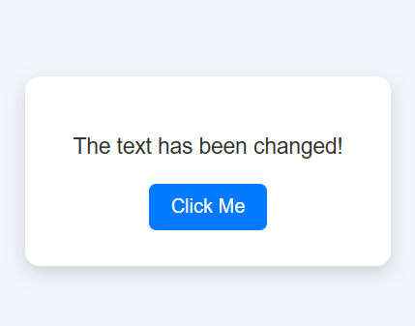

PRACTICAL ASSIGNMENT 5 ( WEB DEVELOPMENT)

QUESTION 1… Write steps to create account in netlify and upload any one project(file).

ANSWER . Title:
To create an account on Netlify and upload (deploy) a project file.

Aim:
The aim of this practical is to create an account on Netlify and deploy any one static project file (HTML/CSS/JavaScript) to host it online.

Objective:
To understand cloud-based web hosting

To learn how to deploy a static website using Netlify
To make a project available on the internet using a live URL Software / Requirements:
Computer or Laptop

Internet Connection

Web Browser (Chrome / Firefox) Gmail or GitHub Account
One static project folder (HTML, CSS, JS)

Theory:
Netlify is a cloud-based web hosting platform used to deploy and host static websites. It supports HTML, CSS, and JavaScript projects and provides free hosting with a live URL. Netlify allows users to deploy projects manually or through GitHub integration. It is widely used by developers due to its simplicity, security, and fast deployment process.

Static websites do not require a database or server-side scripting. Netlify automatically builds and deploys static files and makes them accessible on the internet. It also provides features like automatic HTTPS, custom domains, and continuous deployment.

Steps to Create an Account on Netlify:
Open any web browser on your computer.

Type www.netlify.com in the address bar and press Enter. Click on the “Sign Up” button available on the homepage. Choose a signup method such as Email, Google, or GitHub.
Enter your valid email ID and password (if using email signup). Verify your email address if required.
After verification, Netlify will redirect you to the Dashboard. Your Netlify account is now created successfully.
Steps to Upload and Deploy a Project on Netlify: Login to your Netlify account.

On the Netlify dashboard, click on “Add new site”. Select the option “Deploy manually”.
Prepare your project folder ensuring it contains an index.html file. Drag and drop the complete project folder into the upload section. Netlify will start uploading and deploying the project automatically. After deployment, a unique live URL will be generated.

Click on the provided URL to view your deployed website online. The project is now successfully hosted on Netlify.
Features of Netlify:
Free hosting for static websites Automatic deployment
Secure HTTPS enabled Easy drag-and-drop upload Provides live website URL Supports custom domain
Advantages of Netlify:
Easy to use and beginner friendly No server configuration required Fast website deployment
Free hosting with SSL security Accessible from anywhere
Result:
The Netlify account was created successfully and the project file was uploaded and deployed. The website is accessible online using the generated live URL.

Conclusion:
Netlify is an efficient and reliable platform for hosting static websites. By following the above steps, any static project can be easily deployed and

shared online. This practical helped in understanding real-time website deployment and cloud hosting.

Application / Use Case: Hosting student projects

Portfolio websites

College practical submissions Small business static websites

